Union County High School Athletic Boosters’

Patriot Pride Golf Scramble

The Union County High School Athletic Boosters have scheduled The 14th Annual Patriot Pride Golf Scramble fundraiser for Sunday, August 7, 2016, at the Liberty Country Club in Liberty, Indiana.

As in the past, we are contacting businesses to request help, either in the form of monetary donations or hole sponsorships. All hole sponsor signs will be professionally screened, with your business logo, if received by July 20th. Cost of sponsorship is as follows:

-- A $100.00 donation gives your business an individual sign that is posted at one of the 18 holes.

-- A $50.00 donation gives your business a ½ hole sponsorship. Your business will share a sign with another business, and the sign will be posted at one of the 18 holes.

If you do not wish to sponsor a sign, but would like to make a monetary donation to support UCHS athletics, any amount is greatly appreciated.

All proceeds earned from this scramble go to the Athletic Boosters to support the various athletic needs at Union County High School. This is the major fundraiser for the Athletic Boosters, and we will appreciate any type of donation your business is able to contribute. The UCHS Athletic Boosters are a 501(c)(3) nonprofit organization. Your donation/contribution is tax-deductible to the extent allowed by law.

Thank you in advance for your contribution in helping to support our student athletes. This event has been a great fundraising success for the past several years, and with your help, we are looking forward to celebrating another successful year.

Please feel free to contact Greg Greene, Committee Co-Chairperson, at 513-638-2992 if you have any questions.

Sincerely,

Golf Scramble Committee
Union County Athletic Boosters

Union County
Athletic Boosters’
14th Annual Golf Outing

___ I would like to sponsor a hole for $100.

___ I would like to sponsor ½ of a hole for $50.

___ I do not wish to sponsor a hole, but I have enclosed a donation.

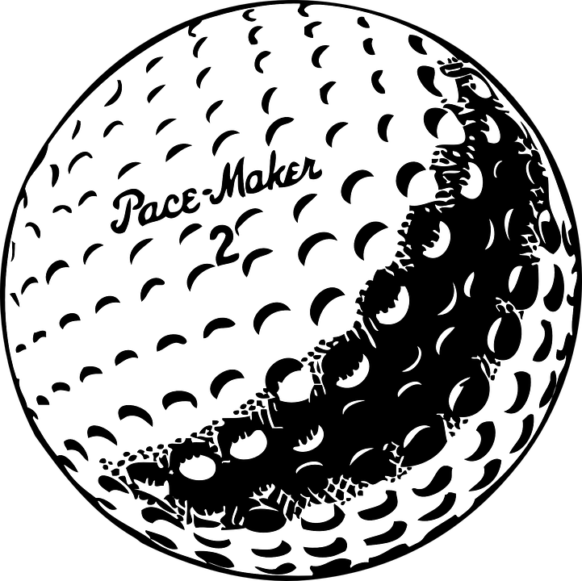

___ I have sponsored in the past, and my logo is the same.

___ I have emailed my logo electronically to cnc.greene@gmail.com.

___ Please just screen my business name on the sign (no logo).

Business/Individual Name: ______________________________

Thank You * Thank You * Thank You * Thank You * Thank You * Thank You * Thank You

